

Academic Task Number: 01 Course code: FINM693

Student’s Roll no: RQ3E23A01 Student’s Reg. no: 12202342

Date of allotment: 13/02/2023 Course title: FUNDAMENTAL ANALYSES

Date of submission: 22/02/2023 Maximum Marks: 30 Academic Task Type: Assignment

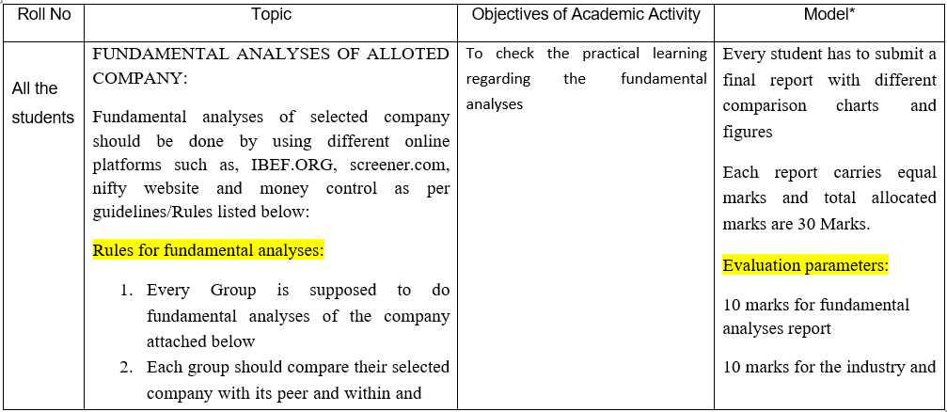

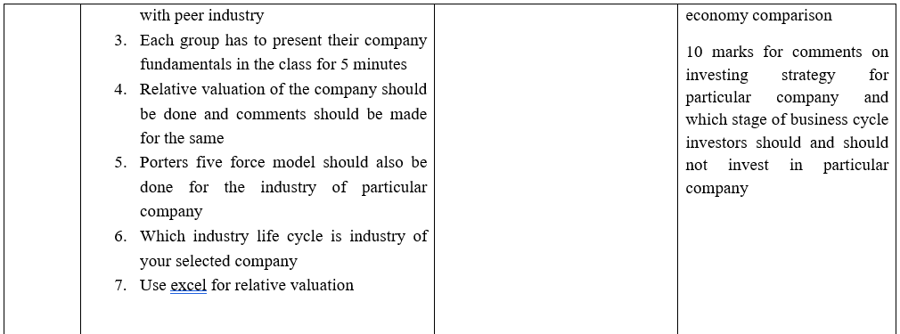

Peer Rating

|  |  |  |  |
| --- | --- | --- | --- |
| **Sl.no** | **Name** | **Roll number** | **Peer rating** |
| **1.** | **Nowneesh T** | RQ3E23A01 |  |
| **2.** | **Praduman Kumar** | RQ3E23A03 |  |
| **3.** | **Abhinav Kumar** | RQ3E23A04 |  |

**Eicher Motors**

Eicher Motors Limited is a leading Indian manufacturer of motorcycles and commercial vehicles. To compare Eicher Motors with its peers and within the industry, we can look at various factors such as financial performance, market share, product portfolio, innovation, and growth prospects.

1. Financial Performance: Eicher Motors has shown consistent growth in its revenue and profitability over the past few years. However, its growth rate has slowed down in recent years due to the impact of the COVID-19 pandemic. In comparison to its peers, such as Hero MotoCorp, Bajaj Auto, and TVS Motor, Eicher Motors has a smaller market share in the two-wheeler segment but has been gaining market share steadily.
2. Market Share: Eicher Motors' market share in the two-wheeler segment in India is around 6%, which is relatively small compared to its peers. However, the company's flagship brand, Royal Enfield, has a strong brand image and a loyal customer base. Royal Enfield has been expanding its global footprint and has a presence in several international markets.
3. Product Portfolio: Eicher Motors' product portfolio consists mainly of motorcycles and commercial vehicles. In the motorcycle segment, the company's focus is on the premium segment with its Royal Enfield brand. In the commercial vehicle segment, the company has a joint venture with Volvo to manufacture trucks and buses.
4. Innovation: Eicher Motors has been investing in research and development to develop new products and technologies. The company has launched several new models under its Royal Enfield brand in recent years, including the Meteor 350, which has received a positive response from customers. Eicher Motors has also been working on developing electric vehicles and has showcased some prototypes in recent years.
5. Growth Prospects: Eicher Motors has a strong growth potential, especially in the international markets. The company has been expanding its global footprint, and its Royal Enfield brand has a strong brand image in several countries. The company has also been investing in new products and technologies, which can help it maintain its growth momentum.

In comparison to its peers, Eicher Motors has a smaller market share in the two-wheeler segment, but its premium brand, Royal Enfield, has a strong brand image and a loyal customer base. The company has been investing in research and development to develop new products and technologies, which can help it maintain its growth momentum in the future.

**Relative Valuation**

Relative valuation of Eicher Motors involves comparing the company's valuation multiples with those of its peers or benchmark indices. The most commonly used valuation multiples for this purpose include Price-to-Earnings (P/E), Price-to-Sales (P/S), Price-to-Book (P/B), and Enterprise Value-to-EBITDA (EV/EBITDA).

As of my knowledge cutoff date of September 2021, Eicher Motors was trading at a P/E ratio of around 38.6x, which was higher than the industry median P/E ratio of 21.2x. However, it's important to note that Eicher Motors is a unique company in the automotive industry, with a strong brand and a leading position in the premium motorcycle segment, which may justify a higher valuation multiple.

Similarly, the company's P/B ratio of 10.4x was also higher than the industry median of 2.4x, indicating that investors are willing to pay a premium for Eicher Motors' strong brand and market position.

In terms of EV/EBITDA, Eicher Motors was trading at a multiple of around 23.8x, which was again higher than the industry median of 9.8x. This suggests that investors are optimistic about the company's growth prospects and are willing to pay a premium for its future earnings potential.

Overall, Eicher Motors appears to be trading at a premium valuation compared to its peers, but this may be justified by the company's strong brand, leading position in the premium motorcycle segment, and growth prospects. It's important for investors to conduct a detailed analysis of the company's financials, competitive landscape, and future growth prospects before making an investment decision.

**Porter Five Forces that Determine Auto & Truck Manufacturers Industry Structure of Eicher Motors**

The Porter Five Forces that determine the industry structure in Auto & Truck Manufacturers are -

1. Threat of substitute products and services in Auto & Truck Manufacturers sector – If the threat of substitute is high then Eicher Motors has to either continuously invest into R&D or it risks losing out to disruptors in the industry.

2. Bargaining power of suppliers in Auto & Truck Manufacturers – If suppliers have strong bargaining power then they will extract higher price from the Eicher Motors. It will impact the potential of Eicher Motors to maintain above average profits in Auto & Truck Manufacturers industry.

3. Bargaining power of buyers of Eicher Motors and Consumer Cyclical sector – If the buyers have strong bargaining power then they usually tend to drive price down thus limiting the potential of the Eicher Motors to earn sustainable profits

4. Rivalry among existing players in Auto & Truck Manufacturers industry – If competition is intense then it becomes difficult for existing players such as Eicher Motors to earn sustainable profits.

5. Threat of new entrants in Auto & Truck Manufacturers industry – if there is strong threat of new entrants in the Auto & Truck Manufacturers industry then current players will be willing to earn lower profits to reduce the threats from new players

**Industry Lifecycle**

Eicher Motors operates in the automotive industry, specifically in the two-wheeler and commercial vehicle segments. The life cycle stage of the automotive industry as a whole can be debated, as different segments within the industry may be at different stages of their life cycle. However, in general, the automotive industry can be considered to be in the maturity stage of its life cycle.

In the mature stage, the industry experiences slower growth and increased competition, as new players enter the market and existing players fight for market share. The focus is on efficiency, cost-cutting, and optimization of existing processes and products, rather than on innovation or disruptive technologies. Companies in the mature stage of the industry life cycle typically have well-established brands, supply chains, and distribution networks, and compete on the basis of price, quality, and customer service. In this context, Eicher Motors can be considered to be in the maturity stage of the industry life cycle, particularly in its domestic market of India, where it faces intense competition from established players like Hero MotoCorp and Bajaj Auto, as well as newer entrants like Royal Enfield. However, Eicher Motors' premium positioning in the motorcycle segment and its international expansion plans suggest that the company is also focused on growth and innovation, which could potentially move it into a later stage of the industry life cycle.

Relative Valuation Using Excel sheet

|  |  |  |  |  |  |  |
| --- | --- | --- | --- | --- | --- | --- |
|  |  | **Market Cap** | **P/S** | **P/E** | **EV/EBITDA** | **EV/EBIT** |
| [Eicher Motors Ltd](https://www.alphaspread.com/security/nse/eichermot/summary) | | 900B INR | 6.9 | 38.6 | 29.2 | 34.7 |
| [Yamaha Motor Co Ltd](https://www.alphaspread.com/security/tse/7272/summary) | | 1.2T JPY | 0.5 | 7.6 | 4.7 | 6 |
| [Harley-Davidson Inc](https://www.alphaspread.com/security/nyse/hog/summary) | | 7B USD | 1.2 | 9.4 | 11.9 | 11.9 |
| [TVS Motor Company Ltd](https://www.alphaspread.com/security/nse/tvsmotor/summary) | | 535B INR | 1.8 | 42.1 | 15.8 | 20.1 |
| [Hero MotoCorp Ltd](https://www.alphaspread.com/security/nse/heromotoco/summary) | | 505B INR | 1.5 | 19.5 | 11.9 | 14.4 |

|  |  |  |  |  |  |
| --- | --- | --- | --- | --- | --- |
|  |  | **ROE** | **ROA** | **ROCE** | **ROIC** |
| [Eicher Motors Ltd](https://www.alphaspread.com/security/nse/eichermot/summary) |  | 19% | 15% | 19% | 18% |
| [Yamaha Motor Co Ltd](https://www.alphaspread.com/security/tse/7272/summary) | | 16% | 8% | 15% | 10% |
| [Harley-Davidson Inc](https://www.alphaspread.com/security/nyse/hog/summary) | | 27% | 7% | 12% | 8% |
| [TVS Motor Company Ltd](https://www.alphaspread.com/security/nse/tvsmotor/summary) | | 28% | 5% | 22% | 10% |
| [Hero MotoCorp Ltd](https://www.alphaspread.com/security/nse/heromotoco/summary) | | 16% | 11% | 18% | 19% |
|  | |  |  |  |  |

Annual Growth of the Industry and Eicher Motors:

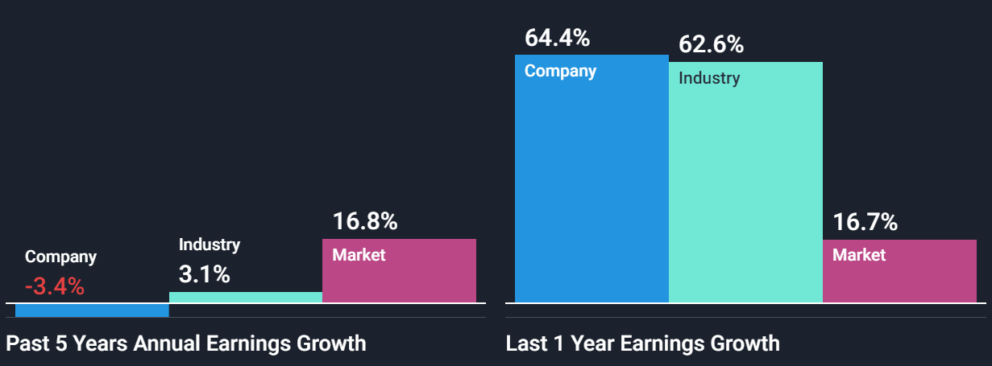

Industry comparision with Eicher Motors

Eicher Motors is a leading player in the Indian automobile industry, particularly in the two-wheeler and commercial vehicle segments. Here's a comparison of Eicher Motors with its industry:

1. Revenue: Eicher Motors has consistently grown its revenue over the years, with a revenue of INR 10,440 crore (approximately USD 1.4 billion) in FY 2020-21. In comparison, the Indian automobile industry as a whole had a revenue of INR 4,04,000 crore (approximately USD 54 billion) in FY 2020-21. This indicates that while Eicher Motors is a significant player in the Indian automobile industry, it is still a relatively small player in the larger industry.
2. Market share: In the two-wheeler segment, Eicher Motors has a market share of around 4.5%, with its flagship brand Royal Enfield being a popular choice among consumers. However, in the commercial vehicle segment, Eicher Motors has a smaller market share of around 6%, with competition from larger players such as Tata Motors and Ashok Leyland.
3. Innovation: Eicher Motors has been investing heavily in research and development, particularly in the area of electric vehicles. The company recently launched its first electric two-wheeler, the Urbanite, and has plans to introduce more electric vehicles in the coming years. However, the larger Indian automobile industry has also been investing in innovation, with major players such as Tata Motors and Mahindra & Mahindra also making significant strides in the electric vehicle space.
4. Global presence: Eicher Motors has a significant presence in international markets, particularly in Europe and the United States, where its Royal Enfield brand has gained a cult following. However, the Indian automobile industry as a whole has been slow to expand globally, with most companies focusing primarily on the domestic market.

Overall, Eicher Motors is a strong player in the Indian automobile industry, with a successful brand in the two-wheeler segment and a growing presence in the commercial vehicle and electric vehicle segments. However, it still faces stiff competition from larger players in the industry, and its revenue is relatively small compared to the overall size of the Indian automobile industry.